How To Create Policy/Apply Policy Limits in e-xclaim

Creating a Policy Limit

- Once in according claim, go the bottom of the claims TAB to Coverage limit under Policy details. (1.1)
- Enter description (eg. Tools, antiques etc….)

- Enter group limit (global amount) – if applicable
OR
- Individual amount (Max limit per item) – if applicable

*** Note that you can fill in both limits if required ***

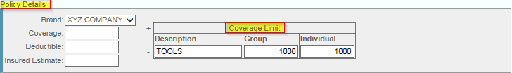
(1.1)

- Hit Save

Applying Policy limits

- Enter according claim
- Select “Contents list” Tab (1.2)
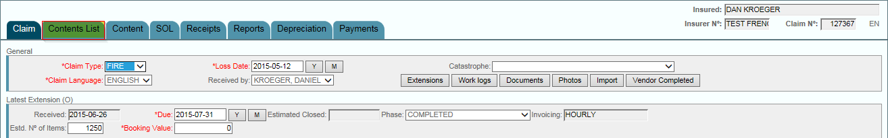
(1.2)

- Select the item/s that fall under the policy limit created previously (see - creating a policy limit) by checking the box to the left of the item. (1.3)
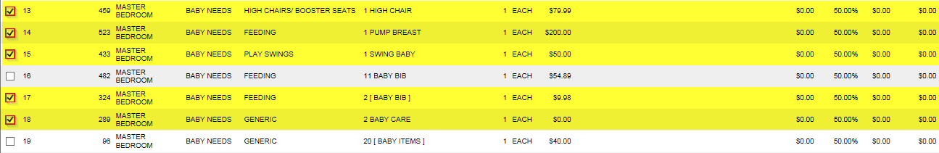
(1.3)
- Once the items that apply to the policy limits have been selected click on “select group actions”

- Select “Include in coverage limit” (1.4)
(1.4)
- Select the coverave limit to which the item/s apply to from the coverage limit drop down. (1.5)
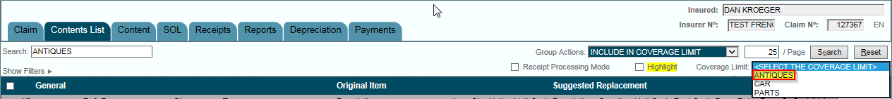

- Hit Save.

