How to Create Bundles

*** Note that only the most recent batch can be deleted from the system, any receipts entered within the batch (if any) would have to be reentered into the previous batch***

- Enter e-xclaim
- Enter according claim
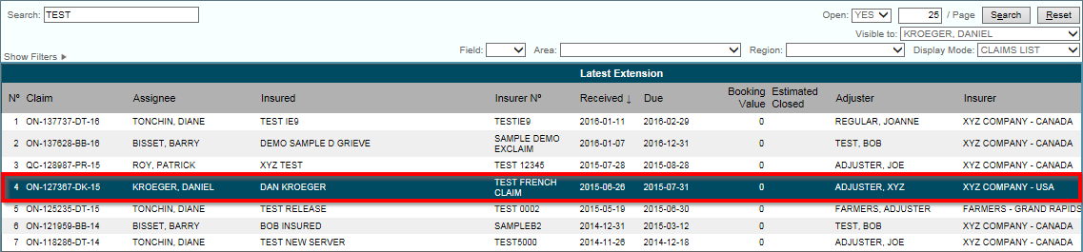

- Select “Contents List” Tab
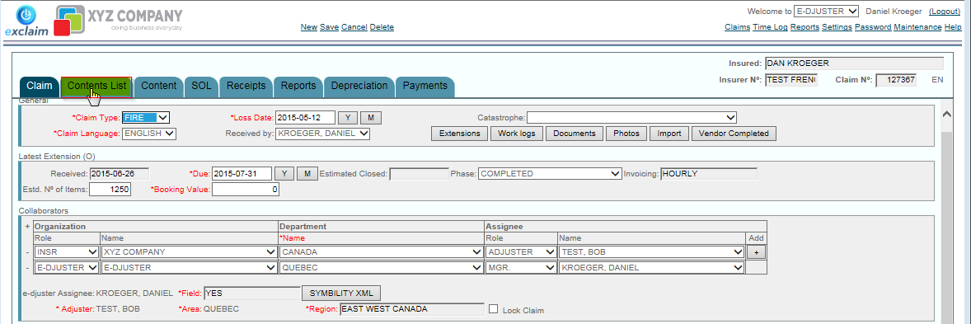

- Once in the Contents list Select all the items you wish to batch together by selecting the checkbox next to the item. (Highlighted in yellow)

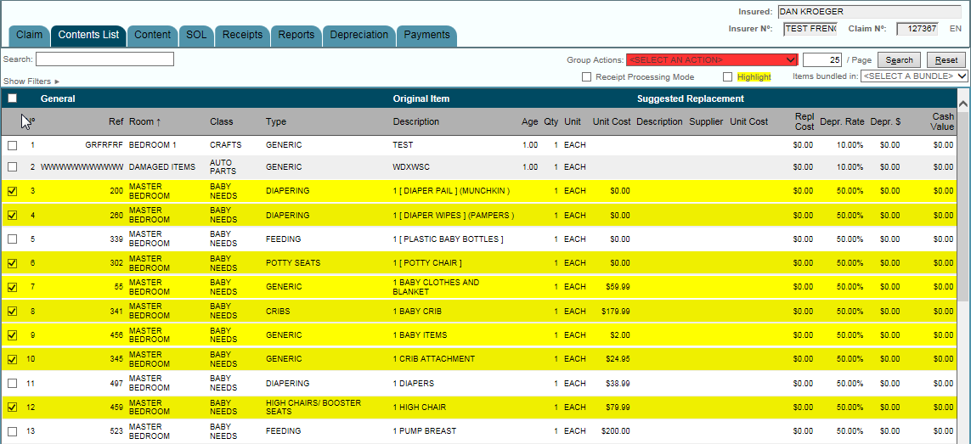

- Select Action at top of Page. (Highlighted in RED)

- Select Create bundle from the drop down menu

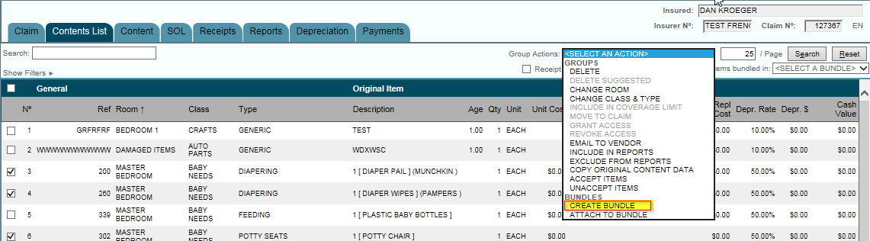

- Fill out next screen with details based on the bundle.

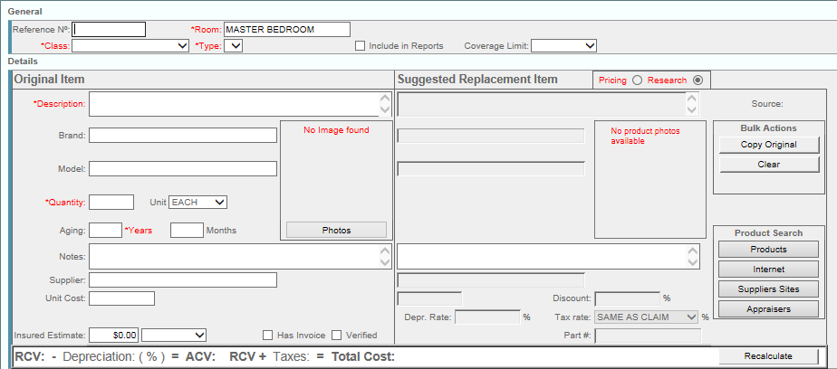

- Hit Save

