Removing batches from receipts

*** Note that only the most recent batch can be deleted from the system, any receipts entered within the batch (if any) would have to be reentered into the previous batch***
- Enter e-xclaim
- Enter according claim
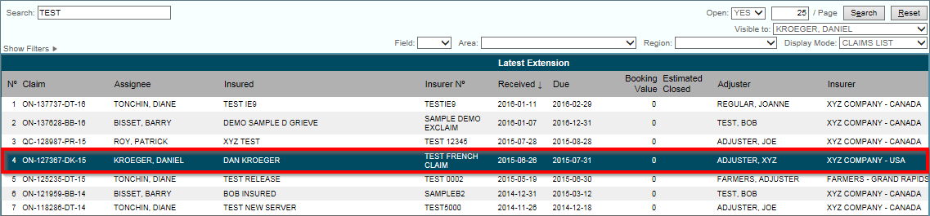
- Select Receipts tab
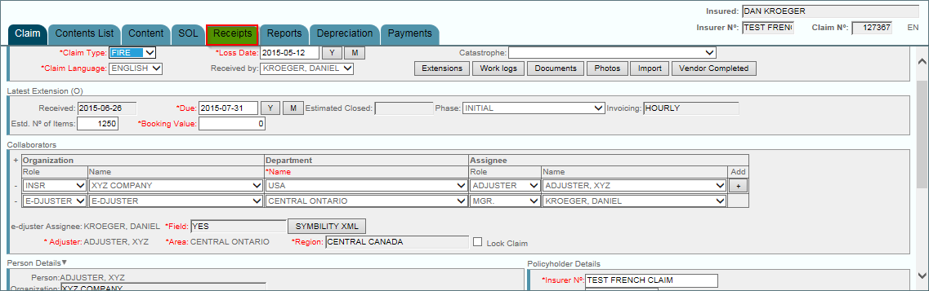

- Select most recent batch ( A,B,C,D, etc….)

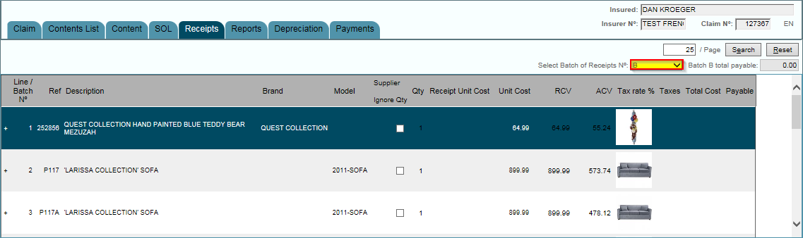

- Once batch is selected hit delete at the top of your page

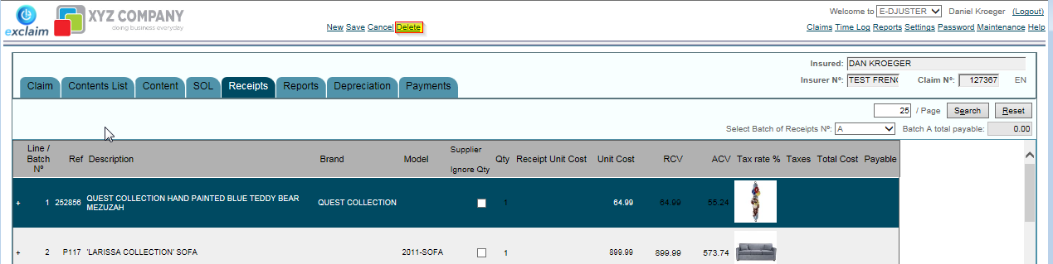
- Hit Save at the top of your screen once you are positive that you want to delete the batch

